Documento Arquitectura de solución.

Recursos hardware.

Recursos software.

Lenguaje de desarrollo: Java

Servidor de aplicaciones: Glassfish

Navegadores para ejecución de aplicación: Google Chrome, Mozilla Firefox, Microsoft Internet Explorer y Edge y Apple Safari.

Herramienta de BI: Web Focus

Sistema operativo: Linux Red Hat.

Protocolo de comunicación de para páginas web: HTTPS

Almacenamientos de los datos.

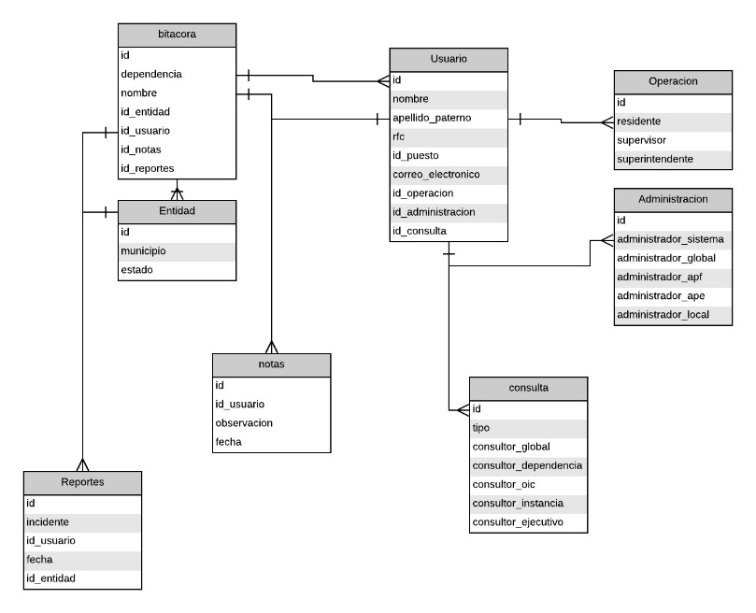

Se decidió por bases de datos en vez de sistemas de archivos, ya que no solo tendremos archivos, también se tiene un registro de usuarios con sus respectivas restricciones, gestor de base de datos será PostgreSQL para mayor facilidad con la conexión la plataforma Webfocus

Módulos

Módulo de almacenamiento.

JDBC

Java Database Connectivity (JDBC) es una interfase de acceso a bases de datos estándar SQL que proporciona un acceso uniforme a una gran variedad de bases de datos relacionales. JDBC también proporciona una base común para la construcción de herramientas y utilidades de alto nivel, compatible con PostgreSQL

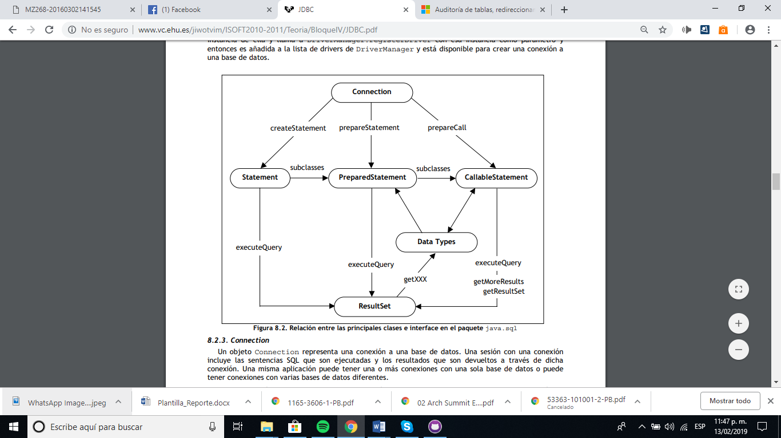

Ssl

Encriptación **SSL**. **SSL** significa "Secure Sockets Layer". **SSL** Definición, Secure Sockets Layer es un**protocolo** diseñado para permitir que las aplicaciones para transmitir información de ida y de manera segura hacia atrás.

PostgreSQL tiene soporte nativo para usar conexiones SSL para cifrar las comunicaciones cliente / servidor para una mayor seguridad. Esto requiere que OpenSSL esté instalado en los sistemas cliente y servidor y que el soporte en PostgreSQL esté habilitado en el momento de la compilación.

Con el soporte SSL compilado, el servidor PostgreSQL puede iniciarse con SSL habilitado configurando el parámetro ssl en ongresql.conf. El servidor escuchará las conexiones normales y las conexiones SSL en el mismo puerto TCP, y negociará con cualquier cliente que se conecte sobre si usar o no SSL. Por defecto, esto es a opción del cliente

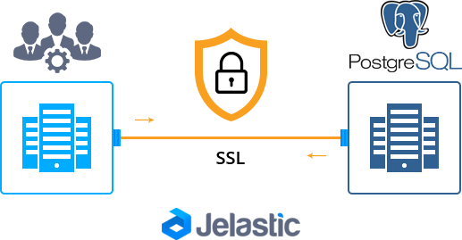

Módulo de conexión

Protocolo https (obligatorio)



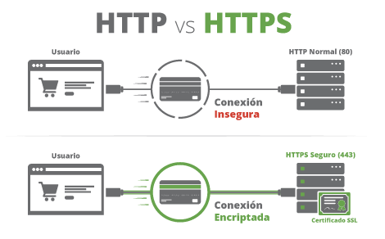

Módulo de seguridad.

Google SQL Dorks – SQL Injection 2018.

Esta lista contiene algunos de las técnicas que Google recomienda tener medidas de seguridad.

view_items.php?id=

home.php?cat=

item_book.php?CAT=

www/index.php?page=

schule/termine.php?view=

goods_detail.php?data=

storemanager/contents/item.php?page_code=

view_items.php?id=

customer/board.htm?mode=

help/com_view.html?code=

n_replyboard.php?typeboard=

eng_board/view.php?T****=

prev_results.php?prodID=

bbs/view.php?no=

gnu/?doc=

zb/view.php?uid=

global/product/product.php?gubun=

m_view.php?ps_db=

productlist.php?tid=

product-list.php?id=

onlinesales/product.php?product_id=

garden_equipment/Fruit-Cage/product.php?pr=

product.php?shopprodid=

product_info.php?products_id=

productlist.php?tid=

showsub.php?id=

productlist.php?fid=

products.php?cat=

products.php?cat=

product-list.php?id=

product.php?sku=

store/product.php?productid=

products.php?cat=

productList.php?cat=

product_detail.php?product_id=

product.php?pid=

view_items.php?id=

more_details.php?id=

county-facts/diary/vcsgen.php?id=

idlechat/message.php?id=

podcast/item.php?pid=

products.php?act=

details.php?prodId=

socsci/events/full_details.php?id=

ourblog.php?categoryid=

mall/more.php?ProdID=

archive/get.php?message_id=

review/review_form.php?item_id=

english/publicproducts.php?groupid=

news_and_notices.php?news_id=

rounds-detail.php?id=

gig.php?id=

board/view.php?no=

index.php?modus=

news_item.php?id=

rss.php?cat=

products/product.php?id=

details.php?ProdID=

els_/product/product.php?id=

store/description.php?iddesc=

socsci/news_items/full_story.php?id=

naboard/memo.php?bd=

bookmark/mybook/bookmark.php?bookPageNo=

board/board.html?table=

kboard/kboard.php?board=

order.asp?lotid=

goboard/front/board_view.php?code=

bbs/bbsView.php?id=

boardView.php?bbs=

eng/rgboard/view.php?&bbs_id=

product/product.php?cate=

content.php?p=

page.php?module=

?pid=

bookpage.php?id=

cbmer/congres/page.php?LAN=

content.php?id=

news.php?ID=

photogallery.php?id=

index.php?id=

product/product.php?product_no=

nyheder.htm?show=

book.php?ID=

print.php?id=

detail.php?id=

book.php?id=

content.php?PID=

more_detail.php?id=

content.php?id=

view_items.php?id=

view_author.php?id=

main.php?id=

english/fonction/print.php?id=

magazines/adult_magazine_single_page.php?magid=

product_details.php?prodid=

magazines/adult_magazine_full_year.php?magid=

products/card.php?prodID=

catalog/product.php?cat_id=

e_board/modifyform.html?code=

community/calendar-event-fr.php?id=

products.php?p=

news.php?id=

StoreRedirect.php?ID=

subcategories.php?id=

tek9.php?

template.php?Action=Item&pid=

topic.php?ID=

tuangou.php?bookid=

type.php?iType=

updatebasket.php?bookid=

updates.php?ID=

view.php?cid=

view_cart.php?title=

view_detail.php?ID=

viewcart.php?CartId=

viewCart.php?userID=

viewCat_h.php?idCategory=

viewevent.php?EventID=

viewitem.php?recor=

viewPrd.php?idcategory=

ViewProduct.php?misc=

voteList.php?item_ID=

whatsnew.php?idCategory=

WsAncillary.php?ID=

WsPages.php?ID=noticiasDetalle.php?xid=

sitio/item.php?idcd=

index.php?site=

de/content.php?page_id=

gallerysort.php?iid=

docDetail.aspx?chnum=

index.php?section=

index.php?page=

index.php?page=

en/publications.php?id=

events/detail.php?ID=

forum/profile.php?id=

media/pr.php?id=

content.php?ID=

cloudbank/detail.php?ID=

pages.php?id=

news.php?id=

beitrag_D.php?id=

content/index.php?id=

index.php?i=

?action=

index.php?page=

beitrag_F.php?id=

index.php?pageid=

page.php?modul=

detail.php?id=

index.php?w=

index.php?modus=

news.php?id=

news.php?id=

aktuelles/meldungen-detail.php?id=

item.php?id=

obio/detail.php?id=

page/de/produkte/produkte.php?prodID=

packages_display.php?ref=

shop/index.php?cPath=

modules.php?bookid=

view/7/9628/1.html?reply=

product_details.php?prodid=

catalog/product.php?pid=

rating.php?id=

?page=

catalog/main.php?cat_id=

index.php?page=

detail.php?prodid=

products/product.php?pid=

news.php?id=

book_detail.php?BookID=

catalog/main.php?cat_id=

catalog/main.php?cat_id=

default.php?cPath=

catalog/main.php?cat_id=

catalog/main.php?cat_id=

category.php?catid=

categories.php?cat=

categories.php?cat=

detail.php?prodID=

detail.php?id=

category.php?id=

hm/inside.php?id=

index.php?area_id=

gallery.php?id=

products.php?cat=

products.php?cat=

media/pr.php?id=

books/book.php?proj_nr=

products/card.php?prodID=

general.php?id=

news.php?t=

usb/devices/showdev.php?id=

content/detail.php?id=

templet.php?acticle_id=

news/news/title_show.php?id=

product.php?id=

index.php?url=

cryolab/content.php?cid=

ls.php?id=

s.php?w=

abroad/page.php?cid=

bayer/dtnews.php?id=

news/temp.php?id=

index.php?url=

book/bookcover.php?bookid=

index.php/en/component/pvm/?view=

product/list.php?pid=

cats.php?cat=

software_categories.php?cat_id=

print.php?sid=

about.php?cartID=

accinfo.php?cartId=

acclogin.php?cartID=

add.php?bookid=

add_cart.php?num=

addcart.php?

addItem.php

add-to-cart.php?ID=

addToCart.php?idProduct=

addtomylist.php?ProdId=

adminEditProductFields.php?intProdID=

advSearch_h.php?idCategory=

affiliate.php?ID=

affiliate-agreement.cfm?storeid=

affiliates.php?id=

ancillary.php?ID=

archive.php?id=

article.php?id=

phpx?PageID

basket.php?id=

Book.php?bookID=

book_list.php?bookid=

book_view.php?bookid=

BookDetails.php?ID=

browse.php?catid=

browse_item_details.php

Browse_Item_Details.php?Store_Id=

buy.php?

buy.php?bookid=

bycategory.php?id=

cardinfo.php?card=

cart.php?action=

cart.php?cart_id=

news.php?id=

aktuelles/meldungen-detail.php?id=

item.php?id=

obio/detail.php?id=

page/de/produkte/produkte.php?prodID=

packages_display.php?ref=

shop/index.php?cPath=

modules.php?bookid=

product-range.php?rangeID=

en/news/fullnews.php?newsid=

deal_coupon.php?cat_id=

show.php?id=

blog/index.php?idBlog=

redaktion/whiteteeth/detail.php?nr=

HistoryStore/pages/item.php?itemID=

aktuelles/veranstaltungen/detail.php?id=

tecdaten/showdetail.php?prodid=

?id=

rating/stat.php?id=

content.php?id=

viewapp.php?id=

item.php?id=

news/newsitem.php?newsID=

FernandFaerie/index.php?c=

show.php?id=

?cat=

categories.php?cat=

category.php?c=

product_info.php?id=

prod.php?cat=

store/product.php?productid=

browsepr.php?pr=

product-list.php?cid=

products.php?cat_id=

product.php?ItemID=

view-event.php?id=

content.php?id=

book.php?id=

page/venue.php?id=

print.php?sid=

colourpointeducational/more_details.php?id=

print.php?sid=

browse/book.php?journalID=

section.php?section=

bookDetails.php?id=

profiles/profile.php?profileid=

event.php?id=

gallery.php?id=

category.php?CID=

corporate/newsreleases_more.php?id=

print.php?id=

view_items.php?id=

more_details.php?id=

county-facts/diary/vcsgen.php?id=

idlechat/message.php?id=

podcast/item.php?pid=

products.php?act=

details.php?prodId=

socsci/events/full_details.php?id=

ourblog.php?categoryid=

mall/more.php?ProdID=

archive/get.php?message_id=

review/review_form.php?item_id=

english/publicproducts.php?groupid=

news_and_notices.php?news_id=

rounds-detail.php?id=

gig.php?id=

board/view.php?no=

index.php?modus=

news_item.php?id=

rss.php?cat=

products/product.php?id=

details.php?ProdID=

els_/product/product.php?id=

store/description.php?iddesc=

socsci/news_items/full_story.php?id=

modules/forum/index.php?topic_id=

feature.php?id=

products/Blitzball.htm?id=

profile_print.php?id=

questions.php?questionid=

html/scoutnew.php?prodid=

main/index.php?action=

********.php?cid=

********.php?cid=

news.php?type=

index.php?page=

viewthread.php?tid=

summary.php?PID=

news/latest_news.php?cat_id=

index.php?cPath=

category.php?CID=

index.php?pid=

more_details.php?id=

specials.php?osCsid=

search/display.php?BookID=

articles.php?id=

print.php?sid=

page.php?id=

more_details.php?id=

newsite/pdf_show.php?id=

shop/category.php?cat_id=

shopcafe-shop-product.php?bookId=

shop/books_detail.php?bookID=

index.php?cPath=

more_details.php?id=

news.php?id=

more_details.php?id=

shop/books_detail.php?bookID=

more_details.php?id=

blog.php?blog=

index.php?pid=

prodotti.php?id_cat=

category.php?CID=

more_details.php?id=

poem_list.php?bookID=

more_details.php?id=

content.php?categoryId=

authorDetails.php?bookID=

press_release.php?id=

item_list.php?cat_id=

colourpointeducational/more_details.php?id=

index.php?pid=

download.php?id=

shop/category.php?cat_id=

i-know/content.php?page=

store/index.php?cat_id=

yacht_search/yacht_view.php?pid=

pharmaxim/category.php?cid=

print.php?sid=

specials.php?osCsid=

store.php?cat_id=

category.php?cid=

displayrange.php?rangeid=

product.php?id=

csc/news-details.php?cat=

products-display-details.php?prodid=

stockists_list.php?area_id=

news/newsitem.php?newsID=

index.php?pid=

newsitem.php?newsid=

category.php?id=

news/newsitem.php?newsID=

details.php?prodId=

publications/publication.php?id=

purelydiamond/products/category.php?cat=

category.php?cid=

product/detail.php?id=

news/newsitem.php?newsID=

details.php?prodID=

item.php?item_id=

edition.php?area_id=

page.php?area_id=

view_newsletter.php?id=

feedback.php?title=

freedownload.php?bookid=

fullDisplay.php?item=

getbook.php?bookid=

GetItems.php?itemid=

giftDetail.php?id=

help.php?CartId=

home.php?id=

index.php?cart=

index.php?cartID=

index.php?ID=

info.php?ID=

item.php?eid=

item.php?item_id=

item.php?itemid=

item.php?model=

item.php?prodtype=

item.php?shopcd=

item_details.php?catid=

item_list.php?maingroup

item_show.php?code_no=

itemDesc.php?CartId=

itemdetail.php?item=

itemdetails.php?catalogid=

learnmore.php?cartID=

links.php?catid=

list.php?bookid=

List.php?CatID=

listcategoriesandproducts.php?idCategory=

modline.php?id=

myaccount.php?catid=

updates.php?ID=

view.php?cid=

view_cart.php?title=

view_detail.php?ID=

viewcart.php?CartId=

viewCart.php?userID=

viewCat_h.php?idCategory=

viewevent.php?EventID=

viewitem.php?recor=

viewPrd.php?idcategory=

ViewProduct.php?misc=

voteList.php?item_ID=

whatsnew.php?idCategory=

WsAncillary.php?ID=

WsPages.php?ID=noticiasDetalle.php?xid=

sitio/item.php?idcd=

index.php?site=

de/content.php?page_id=

gallerysort.php?iid=

products.php?type=

event.php?id=

showfeature.php?id=

home.php?ID=

tas/event.php?id=

profile.php?id=

details.php?id=

past-event.php?id=

index.php?action=

site/products.php?prodid=

page.php?pId=

resources/vulnerabilities_list.php?id=

site.php?id=

products/index.php?rangeid=

global_projects.php?cid=

publications/view.php?id=

display_page.php?id=

pages.php?ID=

lmsrecords_cd.php?cdid=

product.php?prd=

cat/?catid=

products/product-list.php?id=

debate-detail.php?id=

cbmer/congres/page.php?LAN=

content.php?id=

news.php?ID=

photogallery.php?id=

index.php?id=

product/product.php?product_no=

nyheder.htm?show=

book.php?ID=

print.php?id=

detail.php?id=

book.php?id=

content.php?PID=

more_detail.php?id=

content.php?id=

view_items.php?id=

view_author.php?id=

main.php?id=

english/fonction/print.php?id=

magazines/adult_magazine_single_page.php?magid=

product_details.php?prodid=

magazines/adult_magazine_full_year.php?magid=

products/card.php?prodID=

catalog/product.php?cat_id=

e_board/modifyform.html?code=

community/calendar-event-fr.php?id=

products.php?p=

news.php?id=

view/7/9628/1.html?reply=

product_details.php?prodid=

catalog/product.php?pid=

rating.php?id=

?page=

catalog/main.php?cat_id=

index.php?page=

detail.php?prodid=

products/product.php?pid=

news.php?id=

book_detail.php?BookID=

catalog/main.php?cat_id=

catalog/main.php?cat_id=

default.php?cPath=

catalog/main.php?cat_id=

catalog/main.php?cat_id=

category.php?catid=

categories.php?cat=

categories.php?cat=

detail.php?prodID=

detail.php?id=

category.php?id=

hm/inside.php?id=

index.php?area_id=

gallery.php?id=

products.php?cat=

products.php?cat=

media/pr.php?id=

books/book.php?proj_nr=

products/card.php?prodID=

general.php?id=

news.php?t=

usb/devices/showdev.php?id=

content/detail.php?id=

templet.php?acticle_id=

news/news/title_show.php?id=

product.php?id=

index.php?url=

cryolab/content.php?cid=

ls.php?id=

s.php?w=

abroad/page.php?cid=

bayer/dtnews.php?id=

news/temp.php?id=

index.php?url=

book/bookcover.php?bookid=

index.php/en/component/pvm/?view=

product/list.php?pid=

cats.php?cat=

software_categories.php?cat_id=

print.php?sid=

docDetail.aspx?chnum=

index.php?section=

index.php?page=

index.php?page=

en/publications.php?id=

events/detail.php?ID=

category.php?c=

main.php?id=

article.php?id=

showproduct.php?productId=

view_item.php?item=

skunkworks/content.php?id=

index.php?id=

item_show.php?id=

publications.php?Id=

index.php?t=

view_items.php?id=

portafolio/portafolio.php?id=

YZboard/view.php?id=

index_en.php?ref=

index_en.php?ref=

category.php?id_category=

main.php?id=

main.php?id=

calendar/event.php?id=

default.php?cPath=

pages/print.php?id=

index.php?pg_t=

_news/news.php?id=

forum/showProfile.php?id=

fr/commande-liste-categorie.php?panier=

downloads/shambler.php?id=

sinformer/n/imprimer.php?id=

More_Details.php?id=

directory/contenu.php?id_cat=

properties.php?id_cat=

forum/showProfile.php?id=

downloads/category.php?c=

index.php?cat=

product_info.php?products_id=

product_info.php?products_id=

product-list.php?category_id=

detail.php?siteid=

projects/event.php?id=

view_items.php?id=

more_details.php?id=

melbourne_details.php?id=

more_details.php?id=

detail.php?id=

more_details.php?id=

home.php?cat=

idlechat/message.php?id=

detail.php?id=

print.php?sid=

more_details.php?id=

default.php?cPath=

events/event.php?id=

brand.php?id=

toynbeestudios/content.php?id=

show-book.php?id=

more_details.php?id=

store/default.php?cPath=

property.php?id=

product_details.php?id=

more_details.php?id=

product.php?shopprodid=

product.php?productid=

product.php?product=

product.php?product_id=

productlist.php?id=

product.php?shopprodid=

garden_equipment/pest-weed-control/product.php?pr=

product.php?shopprodid=

browsepr.php?pr=

productlist.php?id=

kshop/product.php?productid=

product.php?pid=

showproduct.php?prodid=

product.php?productid=

productlist.php?id=

index.php?pageId=

productlist.php?tid=

product-list.php?id=

onlinesales/product.php?product_id=

garden_equipment/Fruit-Cage/product.php?pr=

product.php?shopprodid=

product_info.php?products_id=

productlist.php?tid=

showsub.php?id=

productlist.php?fid=

products.php?cat=

products.php?cat=

product-list.php?id=

product.php?sku=

productlist.php?grpid=

cart/product.php?productid=

db/CART/product_details.php?product_id=

ProductList.php?id=

products/product.php?id=

product.php?shopprodid=

product_info.php?products_id=

product_ranges_view.php?ID=

cei/cedb/projdetail.php?projID=

products.php?DepartmentID=

product.php?shopprodid=

product.php?shopprodid=

product_info.php?products_id=

index.php?news=

education/content.php?page=

Interior/productlist.php?id=

products.php?categoryID=

?pid=

bookpage.php?id=

view_items.php?id=

index.php?pagina=

product.php?prodid=

notify/notify_form.php?topic_id=

php/index.php?id=

content.php?cid=

product.php?product_id=

constructies/product.php?id=

detail.php?id=

php/index.php?id=

index.php?section=

product.php?****=

show_bug.cgi?id=

detail.php?id=

bookpage.php?id=

product.php?id=

today.php?eventid=

main.php?item=

index.php?cPath=

news.php?id=

event.php?id=

print.php?sid=

news/news.php?id=

module/range/dutch_windmill_collection.php?rangeId=

print.php?sid=

show_bug.cgi?id=

product_details.php?product_id=

products.php?groupid=

projdetails.php?id=

product.php?productid=

products.php?catid=

product.php?product_id=

product.php?prodid=

product.php?prodid=

newsitem.php?newsID=

newsitem.php?newsid=

profile.php?id=

********s_in_area.php?area_id=

productlist.php?id=

productsview.php?proid=

rss.php?cat=

pub/pds/pds_view.php?start=

products.php?rub=

ogloszenia/rss.php?cat=

print.php?sid=

product.php?id=

print.php?sid=

magazin.php?cid=

galerie.php?cid=

www/index.php?page=

view.php?id=

content.php?id=

board/read.php?tid=

product.php?id_h=

news.php?id=

index.php?book=

products.php?act=

reply.php?id=

isplay.php?ID=

display.php?ID=

ponuky/item_show.php?ID=

default.php?cPath=

main/magpreview.php?id=

***zine/board.php?board=

content.php?arti_id=

mall/more.php?ProdID=

product.php?cat=

news.php?id=

content/view.php?id=

content.php?id=

index.php?action=

board_view.php?s_board_id=

KM/BOARD/readboard.php?id=

board_view.html?id=

content.php?cont_title=

category.php?catid=

mall/more.php?ProdID=

publications.php?id=

irbeautina/product_detail.php?product_id=

print.php?sid=

index_en.php?id=

bid/topic.php?TopicID=

news_content.php?CategoryID=

front/bin/forumview.phtml?bbcode=

cat.php?cat_id=

stat.php?id=

veranstaltungen/detail.php?id=

more_details.php?id=

english/print.php?id=

print.php?id=

view_item.php?id=

content/conference_register.php?ID=

rss/event.php?id=

event.php?id=

main.php?id=

rtfe.php?siteid=

category.php?cid=

classifieds/detail.php?siteid=

tools/print.php?id=

channel/channel-layout.php?objId=

content.php?id=

resources/detail.php?id=

more_details.php?id=

detail.php?id=

view_items.php?id=

content/programme.php?ID=

detail.php?id=

default.php?cPath=

more_details.php?id=

content.php?id=

view_items.php?id=

default.php?cPath=

book.php?id=

view_items.php?id=

products/parts/detail.php?id=

category.php?cid=

book.html?isbn=

view_item.php?id=

picgallery/category.php?cid=

detail.php?id=

print.php?sid=

displayArticleB.php?id=

knowledge_base/detail.php?id=

bpac/calendar/event.php?id=

mb_showtopic.php?topic_id=

pages.php?id=

content.php?id=

exhibition_overview.php?id=

singer/detail.php?siteid=

Category.php?cid=

detail.php?id=

print.php?sid=

category.php?cid=

more_detail.php?X_EID=

book.php?ISBN=

view_items.php?id=

category.php?cid=

htmlpage.php?id=

story.php?id=

tools/print.php?id=

print.php?sid=

php/event.php?id=

print.php?sid=

articlecategory.php?id=

print.php?sid=

ibp.php?ISBN=

club.php?cid=

view_items.php?id=

aboutchiangmai/details.php?id=

view_items.php?id=

book.php?isbn=

blog_detail.php?id=

event.php?id=

default.php?cPath=

product_info.php?products_id=

shop_display_products.php?cat_id=

print.php?sid=

modules/content/index.php?id=

printcards.php?ID=

events/event.php?ID=

more_details.php?id=

default.php?TID=

general.php?id=

detail.php?id=

event.php?id=

referral/detail.php?siteid=

view_items.php?id=

event.php?id=

view_items.php?id=

category.php?id=

cemetery.php?id=

index.php?cid=

content.php?id=

exhibitions/detail.php?id=

bookview.php?id=

edatabase/home.php?cat=

view_items.php?id=

store/view_items.php?id=

print.php?sid=

events/event_detail.php?id=

view_items.php?id=

detail.php?id=

pages/video.php?id=

about_us.php?id=

recipe/category.php?cid=

view_item.php?id=

en/main.php?id=

print.php?sid=

More_Details.php?id=

category.php?cid=

home.php?cat=

article.php?id=

page.php?id=

print-story.php?id=

psychology/people/detail.php?id=

print.php?sid=

print.php?ID=

article_preview.php?id=

Pages/whichArticle.php?id=

view_items.php?id=

cart.php?id=

cart_additem.php?id=

cart_validate.php?id=

cartadd.php?id=

cat.php?iCat=

catalog.php

catalog.php?CatalogID=

catalog_item.php?ID=

catalog_main.php?catid=

category.php

category.php?catid=

category_list.php?id=

categorydisplay.php?catid=

checkout.php?cartid=

checkout.php?UserID=

checkout_confirmed.php?order_id=

checkout1.php?cartid=

comersus_listCategoriesAndProducts.php?idCategory=

comersus_optEmailToFriendForm.php?idProduct=

comersus_optReviewReadExec.php?idProduct=

comersus_viewItem.php?idProduct=

comments_form.php?ID=

contact.php?cartId=

content.php?id=

customerService.php?****ID1=

default.php?catID=

description.php?bookid=

details.php?BookID=

details.php?Press_Release_ID=

details.php?Product_ID=

details.php?Service_ID=

display_item.php?id=

displayproducts.php

downloadTrial.php?intProdID=

emailproduct.php?itemid=

emailToFriend.php?idProduct=

events.php?ID=

faq.php?cartID=

faq_list.php?id=

faqs.php?id=

shippinginfo.php?CartId=

shop.php?a=

shop.php?action=

shop.php?bookid=

shop.php?cartID=

shop_details.php?prodid=

shopaddtocart.php

shopaddtocart.php?catalogid=

shopbasket.php?bookid=

shopbycategory.php?catid=

shopcart.php?title=

shopcreatorder.php

shopcurrency.php?cid=

shopdc.php?bookid=

shopdisplaycategories.php

shopdisplayproduct.php?catalogid=

shopdisplayproducts.php

shopexd.php

shopexd.php?catalogid=

shopping_basket.php?cartID=

shopprojectlogin.php

shopquery.php?catalogid=

shopremoveitem.php?cartid=

shopreviewadd.php?id=

shopreviewlist.php?id=

ShopSearch.php?CategoryID=

shoptellafriend.php?id=

shopthanks.php

shopwelcome.php?title=

show_item.php?id=

show_item_details.php?item_id=

showbook.php?bookid=

showStore.php?catID=

shprodde.php?SKU=

specials.php?id=

store.php?id=

store_bycat.php?id=

store_listing.php?id=

Store_ViewProducts.php?Cat=

store-details.php?id=

storefront.php?id=

storefronts.php?title=

storeitem.php?item=

StoreRedirect.php?ID=

subcategories.php?id=

tek9.php?

template.php?Action=Item&pid=

topic.php?ID=

tuangou.php?bookid=

type.php?iType=

updatebasket.php?bookid=

forum/profile.php?id=

media/pr.php?id=

content.php?ID=

cloudbank/detail.php?ID=

pages.php?id=

news.php?id=

beitrag_D.php?id=

content/index.php?id=

index.php?i=

?action=

index.php?page=

beitrag_F.php?id=

index.php?pageid=

page.php?modul=

detail.php?id=

index.php?w=

index.php?modus=

store/product.php?productid=

products.php?cat=

productList.php?cat=

product_detail.php?product_id=

product.php?pid=

wiki/pmwiki.php?page****=

summary.php?PID=

message/comment_threads.php?postID=

artist_art.php?id=

products.php?cat=

index.php?option=

ov_tv.php?item=

index.php?lang=

showproduct.php?cat=

index.php?lang=

product.php?bid=

product.php?bid=

cps/rde/xchg/tm/hs.xsl/liens_detail.html?lnkId=

item_show.php?lid=

?pagerequested=

downloads.php?id=

print.php?sid=

print.php?sid=

product.php?intProductID=

productList.php?id=

product.php?intProductID=

more_details.php?id=

more_details.php?id=

books.php?id=

index.php?offs=

mboard/replies.php?parent_id=

Computer Science.php?id=

news.php?id=

pdf_post.php?ID=

reviews.php?id=

art.php?id=

prod.php?cat=

event_info.php?p=

Para web

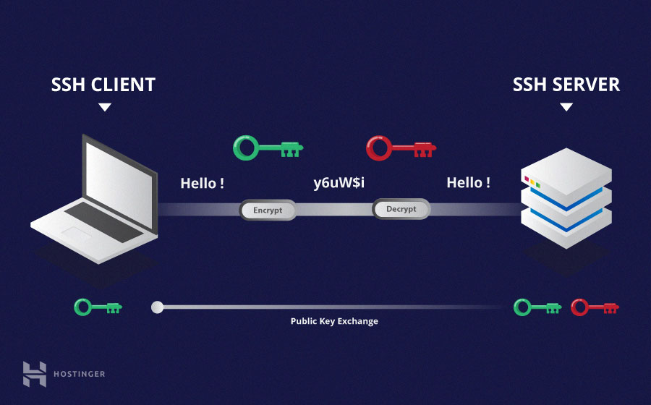

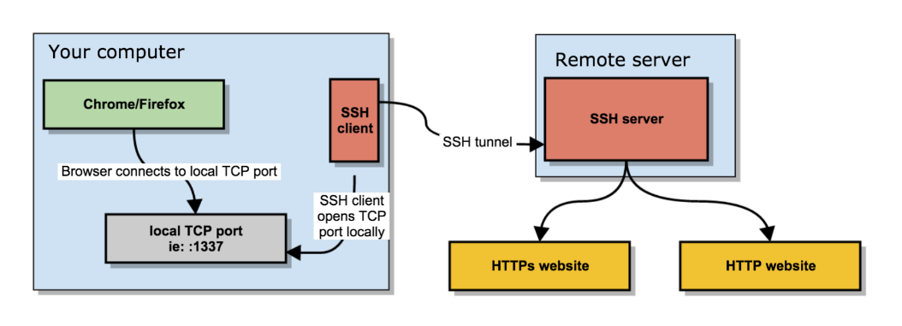

SSH o Secure Shell, es un protocolo de administración remota que permite a los usuarios controlar y modificar sus servidores remotos a través de Internet. El servicio se creó como un reemplazo seguro para el Telnet sin cifrar y utiliza técnicas criptográficas para garantizar que todas las comunicaciones hacia y desde el servidor remoto sucedan de manera encriptada. Proporciona un mecanismo para autenticar un usuario remoto, transferir entradas desde el cliente al host y retransmitir la salida de vuelta al cliente.

Módulos de monitoreo de obra pública.